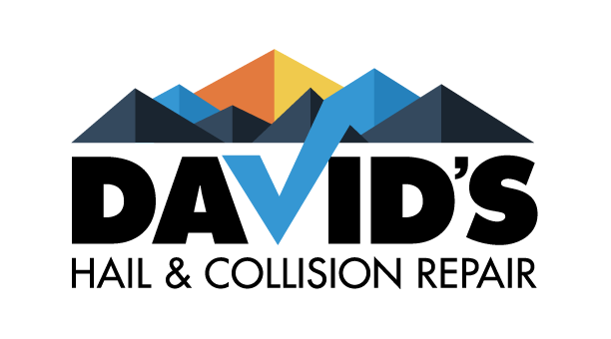

2331 W. Hampden Ave, unit 177
Englewood CO. 80110
Name ______________________ Date in______________________
Address ____________________ Phone # _____________________
___________________________ Cell # _______________________
Insurance Co. _______________ Claim # _____________________
Vehicle year/make/model_______________________________________________________
Vin#________________________________________________________________________
Method of payment:
All deductibles, customer paid repairs, betterment and insurance repairs must be paid in full by the following means: Cash, Insurance check, Cashier’s check or Credit card.
Authorized and Accepted:
David’s Hail and Collision is hereby authorized to make specified repairs to the above vehicle. I understand that payment in full or signature on an authorization for payment to be made directly to David’s Hail and Collision will be due before the release of the vehicle including supplemental damage charges. I hereby grant employees of David’s Hail and Collision permission to operate the vehicle herein described for the purpose to repair operations and/or inspection. An express mechanic lien is hereby acknowledged on the above vehicle to secure the amount of repairs hereto. David’s Hail and Collision will not be held responsible for loss or damage to vehicle or articles left in vehicle in case of fire, theft, accident or any other cause beyond their control. I authorize all supplements payable directly to David’s Hail and Collision. I authorize David’s Hail and Collision to act as Power of Attorney to sign insurance checks to pay for damages to above vehicle.

______________________________ _____________________________
Vehicle Owner Signature Date

